Final Project Plan B - Food? Online Shop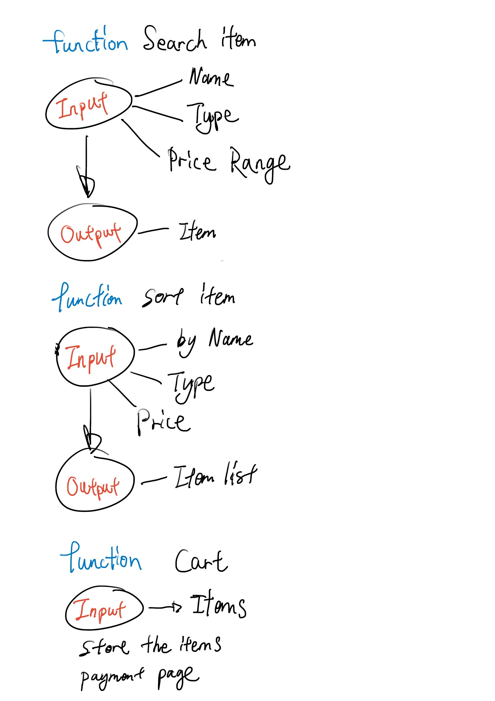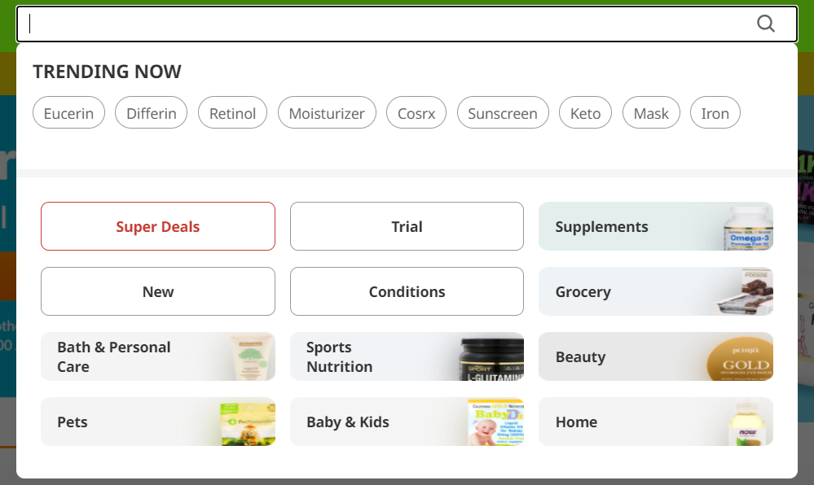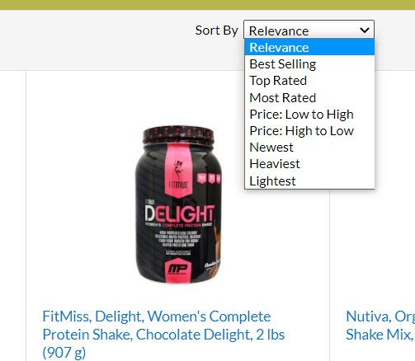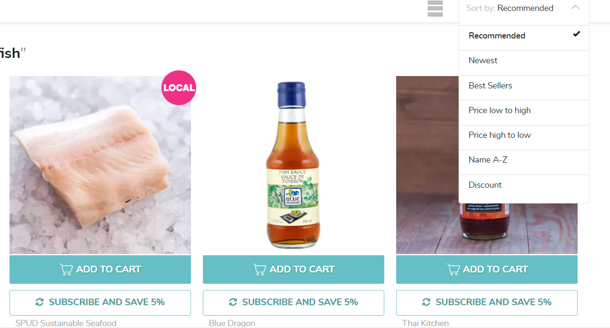

Ref

<https://ca.iherb.com/>

<https://www.spud.ca/index.cfm?login=0&goto=/index.cfm>

<https://www.amazon.com/>